

INTERNSHIP REPORT
ON
ACCOUNTING
By
VAGHASIYA HARSH CHANDUBHAI
B.Com SEM-6
Major Discipline commerce (Roll No. 58)
PKM college of Technology & B.ed.
(Affiliated to Bhakta Kavi Narsinh Mehta University)
Name of the Internship Supervisor:
Prof. Kavita R. Gardharia
Name of the Internship Mentor:
Kishan Patel
Name of the Skill Knowledge Provider:
Time square Ahmedabad
Year of submission:2026
CERTIFICATE

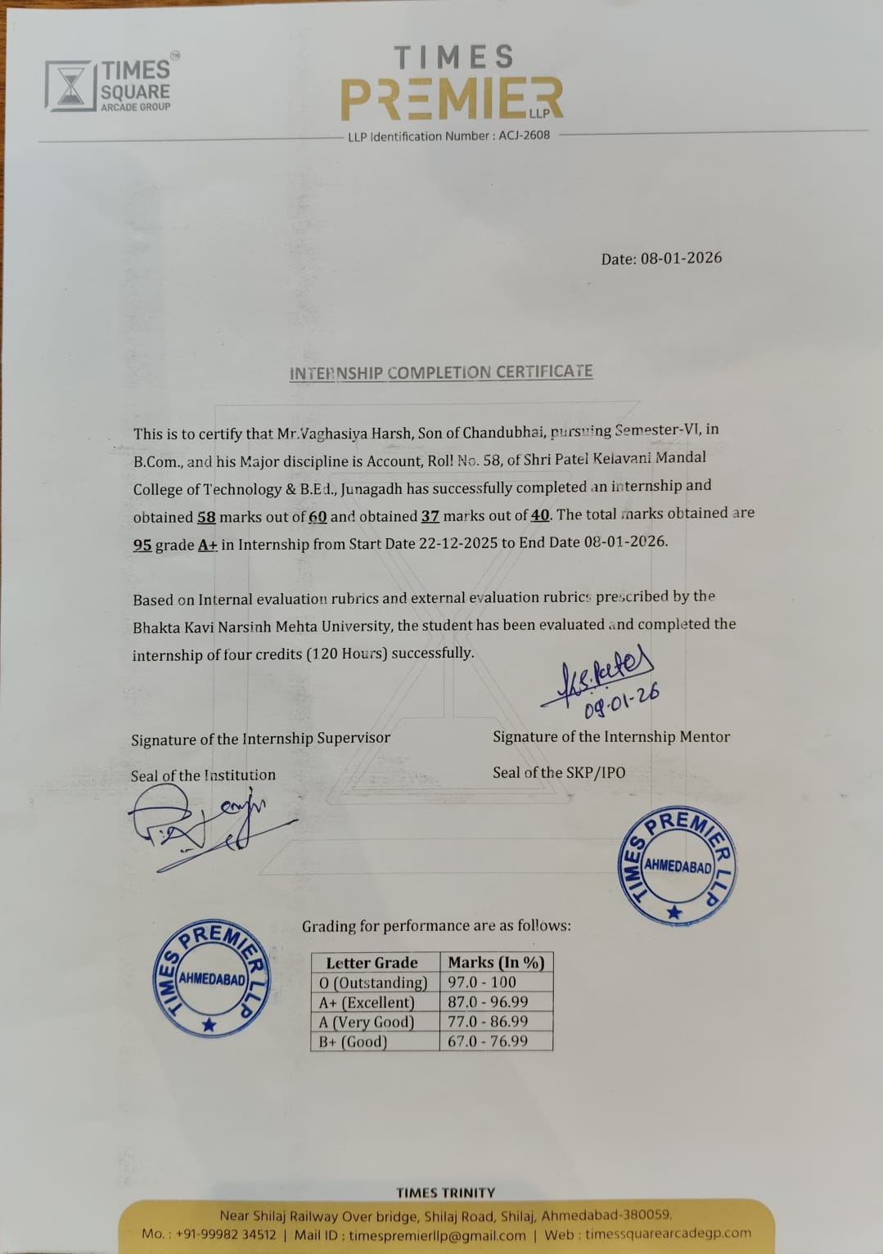

ACKNOWLEDGMENTS
The internship opportunity at the Chartered Accountants firm has been a valuable phase of professional learning and personal growth, and this report is the outcome of the guidance and Support received from many people.​
First and foremost, sincere gratitude is expressed to the respected Principal and faculty members of the college for providing the opportunity to undergo an internship in a ACCOUNTING firm as a part of the academic curriculum. Special thanks are also extended to the Internship/Faculty Coordinator for continuous guidance, encouragement and timely support during the entire internship period.​
Heartfelt thanks are conveyed to the Principal/Proprietor of the firm and all the staff members for granting permission to intern in the organisation, for their patient guidance, and for sharing their practical knowledge in accounting, taxation and audit work. The friendly working environment and constant supervision helped in understanding office discipline, professional ethics and practical application of concepts studied in class.​
Special appreciation is due to parents and family members for their constant motivation, moral support and for allowing and encouraging the completion of this internship successfully. Gratitude is also extended to friends and classmates for their help, discussions and cooperation whenever it was needed during the preparation of this report.​
Although every effort has been taken to prepare this report carefully, any shortcomings or errors are sincerely acknowledged, and constructive suggestions for improvement are welcomed. Finally, thanks are offered to all those who directly or indirectly contributed to the successful completion of this internship and this report.​
Thank you.

INDEX
Sr. No | Topics | Page No
1 | About the organization
2 | Objectives of the internship
3 | Internship work
4 | Learning outcomes
5 | Conclusion
6 | Daily activity log/Attendance
7 | Recommendation letter
8 | Acceptance letter
9 | Permission letter
10 | Evaluation latter

ABOUT THE ORGANIZATION
Name and Nature of the Organization
Time Square Ahmedabad is a prominent real estate and construction organization engaged in the development of commercial and mixed-use infrastructure projects. The organization operates in the field of real estate development, construction, and property management, with a focus on creating modern commercial spaces such as offices, retail showrooms, and business hubs. The company aims to provide high-quality infrastructure that meets the growing commercial and business needs of urban areas.
Brief History and Year of Establishment
Time Square Ahmedabad was established with the objective of contributing to Ahmedabad’s rapidly growing real estate sector. Since its establishment, the organization has focused on delivering well-planned, architecturally sound, and customer-oriented commercial projects. Over the years, Time Square Ahmedabad has built a reputation for reliability, quality construction, and timely project execution, which has helped the organization gain trust among clients, investors, and business owners.
Location and Operational Area
The organization is based in Ahmedabad, Gujarat, one of India’s fastest-growing metropolitan cities. Time Square Ahmedabad operates mainly within Ahmedabad and its surrounding urban development zones. Its projects are strategically located in prime commercial areas such as Thaltej–Shilaj Road, Sindhu Bhavan Road, and S. G. Highway, which are well-connected and rapidly developing business corridors. These locations provide easy accessibility and high commercial value.
Growth and Development of the Organization
Since its inception, Time Square Ahmedabad has shown steady growth through the successful completion of various commercial projects. The organization has continuously adapted to modern construction techniques, innovative designs, and changing market demands. By focusing on quality standards, advanced planning, and customer satisfaction, the company has expanded its project portfolio and strengthened its market presence. Today, Time Square Ahmedabad is recognized for contributing significantly to the commercial infrastructure development of the city and continues to grow by undertaking new and ambitious projects.

Vision of the Organization
The vision of Time Square Ahmedabad is to become a leading real estate developer by creating sustainable, innovative, and world-class commercial infrastructure that enhances urban development and business growth.
Mission of the Organization
The mission of the organization is to:
- Deliver high-quality construction projects using modern technology and best industry practices.
- Ensure timely completion of projects with cost efficiency.
- Maintain transparency and ethical standards in all business operations.
- Provide maximum value and satisfaction to clients, investors, and stakeholders.
Core Values
The core values of Time Square Ahmedabad include:
- Quality Excellence – Commitment to superior construction standards
- Integrity – Ethical and transparent business practices
- Customer Satisfaction – Focus on meeting client requirements
- Innovation – Adoption of modern designs and construction techniques
- Teamwork – Collaboration and mutual respect among employees
Organisational Hierarchy
The organizational structure of Time Square Ahmedabad is well-defined and systematic, ensuring smooth coordination and efficient decision-making. The hierarchy generally consists of:
- Managing Director / Chairman
- Project Director
- General Manager
- Project Managers
- Engineers and Architects
- Accounts and Finance Officers
- Site Supervisors
- Administrative and Support Staff

Major Departments and Their Functions
- Construction & Engineering Department: Responsible for project execution, site supervision, quality control, and safety management.
- Accounts & Finance Department: Handles accounting records, budgeting, cost control, billing, taxation, and financial reporting.
- Purchase & Procurement Department: Manages procurement of construction materials, vendor selection, and inventory control.
- Marketing & Sales Department: Promotes projects, manages client relations, and handles sales activities.
- Administration & HR Department: Oversees human resources, office administration, documentation, and compliance.
Position of Internship Department within the Organisation
During the internship period, I was assigned to the Accounts Department of Time Square Ahmedabad. The Accounts Department plays a vital role in financial planning, cost management, and maintaining accurate accounting records for construction projects. It works in close coordination with the construction, purchase, and management teams to ensure smooth financial operations and effective project cost control.
Major Activities / Services / Products of the Organization
Time Square Ahmedabad is actively engaged in the development of commercial and mixed-use real estate projects. The major activities of the organization include project planning, architectural design coordination, construction execution, quality control, and project management. The organization develops commercial properties such as office spaces, retail showrooms, and business complexes equipped with modern amenities. In addition, it also provides services related to property management, maintenance coordination, and customer support for commercial units.
Target Customers / Beneficiaries
The primary target customers of Time Square Ahmedabad are business owners, corporate offices, entrepreneurs, retailers, investors, and professionals seeking well-designed commercial spaces. The beneficiaries also include local vendors, contractors, engineers, and employees who are directly or indirectly associated with construction and real estate activities. The organization further benefits the urban community by contributing to infrastructure development and economic growth.
Importance of the Organization in Industry or Society
Time Square Ahmedabad plays an important role in the real estate and construction industry by providing high-quality commercial infrastructure that supports business expansion and employment generation. The organization contributes to urban development by improving land utilization, enhancing commercial connectivity, and promoting organized business environments. Its projects support economic growth, create job opportunities, and add long-term value to the city’s commercial landscape.
Relevance of the Organization to My Course and Major Subject
The organization is highly relevant to my academic course in Accounting / Commerce as construction and real estate projects involve extensive financial planning, cost control, budgeting, taxation, and accounting processes. The Accounts Department handles activities such as voucher entry, expense recording, material purchase accounting, GST compliance, and financial reporting. This exposure helps in understanding practical applications of accounting principles, tally software usage, and financial management in a real business environment.
Reason for Selecting This Organization for Internship
I selected Time Square Ahmedabad for my internship because it provides practical exposure to accounting functions within the construction and real estate sector. The organization offers a professional work environment where theoretical knowledge gained in college can be applied to real-life business situations. Additionally, working with experienced professionals and handling actual accounting records has helped enhance my practical skills, industry understanding, and career readiness.

OBJECTIVES OF THE INTERNSHIP
Purpose of Choosing the Organization
The primary purpose of choosing Time Square Ahmedabad for the internship was to gain practical exposure to the construction and real estate industry, particularly in the area of accounting and financial management. The organization provides a real working environment where theoretical concepts learned in the classroom can be applied to real business operations. Selecting this organization helped in understanding how accounting functions are performed in a construction-based organization.
Academic Objectives
The academic objective of the internship was to bridge the gap between theoretical knowledge and practical application. Through this internship, I aimed to understand practical aspects of accounting such as voucher entry, expense recording, billing, GST compliance, and basic financial reporting. It also helped in understanding how accounting standards and principles are applied in real organizational scenarios.
Skill Development Objectives
One of the key objectives of the internship was to develop professional and technical skills. This included improving practical skills in accounting software such as Tally Prime, enhancing data entry accuracy, understanding documentation procedures, and developing analytical skills related to cost control and financial records. The internship also helped in developing soft skills such as communication, teamwork, time management, and professional discipline.
Employability-Related Objectives
The employability-related objective of the internship was to gain industry-relevant experience that would enhance future job opportunities. Exposure to real accounting tasks, understanding organizational workflows, and working under professional supervision helped in building confidence and workplace readiness. The internship also provided insight into career opportunities in accounting and finance within the construction and real estate sector.

INTERNSHIP WORK
During my internship at Time Square Ahmedabad, I was assigned to the Accounts Department, where I gained practical exposure to accounting and financial activities related to construction and real estate projects. The internship provided hands-on experience in maintaining financial records and understanding day-to-day accounting operations within an organization.
- Create company
- Create ledger
- Voucher entries
- Entries of bank statement
- Posting of opening balance in tally.
- RTGS
- Reconciliation
- GST
- GST Reconciliation
- Shop Act
- MS- Excel

During the internship, practical exposure was gained in core accounting, taxation, and compliance activities using Tally Prime and MS Excel. The learning began with company creation in Tally, where basic details such as company name, financial year, currency, and statutory features were configured accurately. This was followed by ledger creation, including ledgers for cash, bank, parties, expenses, incomes, and statutory duties like GST.

Hands-on experience was obtained in recording voucher entries, such as payment, receipt, sales, purchase, journal, and contra vouchers. Special focus was given to bank-related entries, including deposits, withdrawals, cheque entries, and RTGS transactions, ensuring correct bank and party ledger impact. Opening balances of assets, liabilities, cash, and bank were properly posted to maintain accurate beginning financial positions.

The process of bank reconciliation was learned by matching company cash book entries with the bank statement, identifying differences due to outstanding cheques, bank charges, and direct credits or debits. Similarly, GST accounting was handled by recording GST-compliant sales and purchase entries, understanding input tax credit, output tax liability, and tax payment procedures. GST reconciliation was performed by matching books of accounts with GST returns to ensure accuracy and compliance.

The internship provided comprehensive practical training in accounting, banking, taxation, and statutory compliance, mainly using Tally Prime and MS Excel. The training began with company creation in Tally, where organizational details such as company name, address, financial year, currency settings, and statutory configurations were entered. Proper configuration ensured accurate accounting and compliance with Indian accounting standards.
The next step involved ledger creation, which included creating ledgers for capital, loans, cash, bank accounts, sundry debtors, sundry creditors, indirect expenses, direct expenses, incomes, and statutory ledgers such as GST, CGST, SGST, and IGST. Understanding correct ledger grouping was emphasized to maintain systematic financial records.
Practical exposure was gained in voucher entries, including sales, purchase, payment, receipt, journal, and contra vouchers. Entries related to bank statements were recorded carefully, such as cheque deposits, withdrawals, bank charges, interest entries, and online transactions. Special focus was given to RTGS transactions, ensuring correct recording of high-value inter-bank transfers with proper narration and date accuracy.
The process of posting opening balances was learned to ensure accurate representation of assets and liabilities at the beginning of the financial year. This included entering opening balances for cash, bank accounts, debtors, creditors, capital, and loans.
Hands-on training was provided in bank reconciliation, where the cash book balance was compared with the bank statement. Differences such as outstanding cheques, direct bank entries, and bank charges were identified and adjusted to reconcile balances accurately.
The internship also covered GST accounting, including GST-enabled sales and purchase entries, input tax credit utilization, output tax liability calculation, and tax payment procedures. GST reconciliation was performed to match books of accounts with GST returns, helping identify mismatches, missing invoices, and incorrect tax credits.
Knowledge of statutory compliance was enhanced through learning about the Shop Act, its registration process, documentation requirements, and importance for legal operation of business entities.

Tally Prime – Company Creation Summary

Company creation in Tally Prime is the first and most important step for maintaining accounts of any business. In this process, basic details of the business such as company name, address, financial year, and currency are entered.

While creating a company, we select the appropriate maintain accounts option, enable GST details, and choose the financial year starting date as per business requirements. Tally Prime also allows setting security features like user access and password if needed.

After successful company creation, the company is ready for further accounting work such as creating ledgers, groups, vouchers, and recording daily transactions. Proper company creation ensures accurate accounting, GST compliance, and correct financial reporting.
​ Exposure was also provided to statutory compliance such as Shop Act registration, understanding its importance for legal business operations. Additionally, MS Excel was extensively used for data entry, ledger analysis, bank statement reconciliation, report preparation, and maintaining accounting records efficiently.

Overall, these activities enhanced practical accounting skills, improved accuracy in financial record-keeping, strengthened understanding of taxation and compliance, and prepared for real-world accounting and finance roles.
Additionally, MS Excel was widely used for preparing accounting reports, maintaining transaction records, bank reconciliation statements, GST working sheets, and data analysis. Functions, formulas, formatting, and reconciliation techniques were applied to improve efficiency and accuracy.
Overall, the internship significantly strengthened practical accounting knowledge, improved understanding of statutory compliance, enhanced software proficiency, and built confidence in handling real-time business accounting operations.

Details to be filled in company creation
A. Name
In this field, we are required to type the name of the company, for example.
XYZ INC.
Primary mailing details
∙ Mailing name
In this field, we are required to type the name of the company, for example.
XYZ INC.
∙ Address
In this data field, we are required to enter the address of the company.
∙ Country
Here we are required to select the country from the list in which the business Operates.
∙ State
In this data field, we have to select the state in which we would comply with statutory laws
∙ Pincode
Pincode of the location where the office exists.
B. Contact details
∙ Phone no
Enter the Company contact number which we would like to display on
Invoices

Mobile no
Enter the Contact number of Managing Person to whom any queries related to Invoicing or Delivery of product, complaint in the product could be reached to
∙ Fax No
Enter the Fax number to which any confirmation statements, ledger copies etc., could be sent and received
∙ E-mail
Enter the company’s email address to which any product inquiry and other communications could be made.
∙ Website
Enter the company’s web address if any C.Books and financial year details
∙ Financial year begins from
In this data field, you have to type the financial year in which you want to create a company. Suppose you may be starting company on December 01 2018, you should enter the financial year from as 01.04.2018.
∙ Book beginning from
In this data field, you have to type the financial year in which you want to create a company. Suppose you may be starting company on December 01 2018, you
should enter the financial year from as 01.04.2018.
o Starting in the middle of the financial year.
o Companies which are migrating from Manual Accounting to TallyERP9.
Accounting Vouchers in Tally
∙ Sales Voucher
∙ Purchase Voucher
∙ Payment Voucher
∙ Receipt Voucher
∙ Contra Voucher
∙Journal Voucher
∙ Credit Note Voucher
∙ Debit Note Voucher
∙ Sales Voucher
Sales voucher is one of the most used accounting vouchers in Tally. Users can create this voucher in two different formats; as an invoice, or as a voucher. The invoice format enables users to print a copy of invoices for customers. The voucher format can be used to store transactional records electronically and it doesn’t need a paper copy for the customer.
∙ Purchase Voucher
Like sales vouchers, purchase voucher belongs to the accounting category and is available in both invoice and voucher formats. Editing and modifying receipt entries in Tally are easy, as its voucher format helps accountants to do so quickly. Moreover, Tally also helps in converting a purchase voucher in the invoice format to the voucher format.
∙ Payment Voucher
The payment voucher is another accounting voucher in Tally that helps create and print cheques against the order. Once the payment voucher gets passed, the corresponding cheque can be printed by clicking on ‘banking’ and then on ‘cheque printing’.

∙ Receipt voucher
When accountants make a receipt voucher in Tally, all the invoices which have pending payments pop up as a reminder. As soon as the client makes the payment through any mode, the receipt can be updated with the payment method details. In addition, all the details of this receipt can be sent to the customer. Thus, receipt vouchers make payment monitoring easy.
∙ Contra Voucher
Contra vouchers are used to withdraw or deposit money in banks with the help of instruments such as cheques/ATM/DD or e-transfer to another account through NEFT/IMPS. With the help of contra vouchers in Tally, accountants can also generate deposit slips for recordkeeping.
Tally also provides exact currency denominations to monitor and print the deposit slip while also depositing the amount.
∙ Journal Voucher
Unlike other vouchers, a journal voucher in Tally can come under the roof of both accounting and inventory vouchers. There are multiple uses of a journal voucher in Tally depending on the type of business it is being used for. It can be found as an optional voucher in Tally to make sales and purchase by accountants. Professionals can also use it for the adjustment or transferring of stock from one warehouse to the other.
∙ Credit Note Voucher
Credit note voucher in Tally has to be enabled manually. It is usually enabled by pressing F11 and they manually configuring its features. Credit note can also be passed by checking the original invoice. When a client is selected, Tally shows the transaction invoice history that have been raised.
∙ Debit Note Voucher
Debit note voucher is one of the most-used types of voucher in Tally ERP 9, that is used for managing purchase returns. With the help of this, accountants can generate a debit note for invoicing as well as a voucher.

1. Bank Statement
Process No 1 –
Create a ledger under bank accounts and then save the same. Process
No 2.
Go to the accounting vouchers menu and then we need to select what kind of voucher do we need to pass using the bank account. One can use 3 voucher type to pass a bank Entry in Tally.ERP 9
Payment –
To make payment entry. Debit the Expenses Ledger (for cash transactions)/Party Ledger (for non-cash transactions) and Credit the Bank. The short cut key to Select Payment Voucher is F5.
Receipt –
To make receipt entry. Debit the Bank Ledger and Credit the Party Ledger (for cash transactions) / Income ledger (for non-cash transactions). The shortcut key to Select Receipt Voucher is F6.
Contra –
Use for the only cash transaction. Debit / Credit Bank /Cash. The Short cut key to Select Contra Voucher is F4.

RTGS (Real Time Gross Settlement)

Introduction
Real Time Gross Settlement (RTGS) is a funds transfer system where the transfer of money or securities takes place from one bank to another on a "real-time" and "gross" basis. This means transactions are processed individually and immediately, without netting with other transactions. RTGS systems are typically managed by central banks and are considered the fastest and safest method of transferring large-value funds.
Key Features
- Real-Time Processing: Transactions are settled instantly as they are initiated.
- Gross Settlement: Each transaction is settled individually, not bundled or netted.
- Final and Irrevocable: Once processed, the payment cannot be reversed.
- High-Value Transfers: Primarily used for large-value transactions, often above a threshold set by the central bank.
- Secure and Reliable: Operated by central banks with robust security protocols.
Objectives
- To reduce settlement risk in high-value transactions.
- To ensure immediate and final transfer of funds.
- To enhance efficiency and stability in the financial system.
- To support monetary policy implementation by central banks.
Advantages
- Speed: Immediate settlement of transactions.
- Certainty: Payments are final and irrevocable.
- Risk Reduction: Eliminates settlement risk associated with deferred net settlement systems.
- Transparency: Clear and traceable transaction records.
RTGS in India
- Introduced by the Reserve Bank of India (RBI) in 2004.
- Available for transactions above ₹2,00,000.
- Operates 24x7, including holidays (since December 2020).
- Widely used for corporate payments, interbank transfers, and high-value individual transactions.
Process Flow
- Initiation: Customer requests RTGS transfer through their bank.
- Validation: Bank verifies details and forwards the request to RBI’s RTGS system.
- Settlement: Funds are transferred instantly from the remitting bank to the receiving bank.
- Confirmation: Both banks and the customer receive confirmation of successful transfer.
Applications
- Corporate payments for suppliers and vendors.
- Interbank settlements.
- High-value personal transactions (property purchase, investments).
- Government and institutional fund transfers.

RTGS has revolutionized the way high-value transactions are conducted by ensuring speed, security, and finality. It plays a crucial role in maintaining trust and efficiency in the banking system and is a backbone of modern financial infrastructure.

BANK RECONCILIATION
These are the most common type of reconciliation and require businesses to reconcile their cash position by comparing the value of recorded bank transactions in their accounting software to those on their monthly bank statements.
❖Bank Reconciliation Procedure Below is step by step procedure for Bank Reconciliation:
⮚ Match the Opening balance as per Bank statement with the books.
⮚ Check and tick all the debit entries as reflected in bank ledger with the
credit entries in Bank Statement, identify which are missed.
⮚ Check and tick all the credit entries as reflected in Bank Ledger with the debit side in the bank statement, identify which are missed.
⮚ Correct the entries which are erroneously passed in Bank Ledger.
⮚ Take the adjusted closing balance of the Bank in Bank Reconciliation
Statement.
⮚ Add back all the UnpresentedCheques and other credits that are not
reflected in Bank Statement but reflected in Bank Ledger.
⮚ Less all the deposit in transit and another debit which is not reflected in Bank Statement but the entry for the same is passed in Books.
⮚ After adjustment of the above amount, you will arrive at Balance as per Bank Statement.

GST
Goods and Services Tax (GST) is a comprehensive indirect tax introduced in India on 1st July 2017. It has replaced multiple indirect taxes such as Value Added Tax (VAT), Service Tax, Excise Duty, and others, bringing them under a single tax system. GST is levied on the supply of goods and services and is applicable throughout the country.
Types of GST
- CGST (Central Goods and Services Tax): Collected by the Central Government.
- SGST (State Goods and Services Tax): Collected by the State Government.
- IGST (Integrated Goods and Services Tax): Applicable on inter-state supply of goods and services.
- UTGST (Union Territory GST): Applicable in Union Territories.
GST Registration
Businesses whose annual turnover exceeds the prescribed limit are required to register under GST. After registration, a unique GST Identification Number (GSTIN) is allotted, which is mandatory for issuing tax invoices, filing returns, and claiming input tax credit.
GST Compliance and Returns
- Issue GST-compliant tax invoices
- Maintain proper records of sales and purchases
- File periodic GST returns such as GSTR-1, GSTR-3B, and GSTR-9
- Pay GST within the due dates to avoid penalties
During my internship at Times Square, Ahmedabad, I learned about the importance of timely GST filing and accurate documentation for smooth business operations.
Input Tax Credit (ITC)
One of the major benefits of GST is Input Tax Credit, which allows businesses to claim credit for the tax paid on purchases against the tax payable on sales. This helps in reducing the overall tax burden and prevents the cascading effect of taxes.
Importance of GST for Businesses at Times Square
GST plays a significant role in the functioning of businesses operating at Times Square, Ahmedabad, such as retail stores, offices, and service providers. Proper GST compliance ensures:
- Legal business operations
- Transparency in transactions
- Smooth coordination with suppliers and customers
GST Reconciliation
Introduction
GST Reconciliation is an important compliance activity under the Goods and Services Tax (GST) system. It involves matching the details of outward supplies, inward supplies, tax liability, and input tax credit (ITC) as per the books of accounts with the data filed on the GST portal. During my internship at Time Square, Ahmedabad, I gained practical exposure to the GST reconciliation process and understood its importance in ensuring accurate tax reporting and avoiding penalties.
Objective of GST Reconciliation
The main objectives of GST reconciliation are:
- To ensure accuracy between books of accounts and GST returns
- To identify mismatches in sales, purchases, and input tax credit
- To prevent excess or short payment of GST
- To ensure compliance with GST laws and rules
- To avoid interest, penalties, and notices from tax authorities
Process of GST Reconciliation
During my internship, the GST reconciliation process was carried out in the following manner:
- Reconciliation of GSTR-1 and Books of Accounts: Sales as per books were matched with outward supplies reported in GSTR-1. Differences due to omitted invoices, wrong GSTIN, incorrect taxable value, or tax rate errors were identified and corrected.
- Reconciliation of GSTR-3B and GSTR-1: The tax liability declared in GSTR-3B was compared with GSTR-1 to ensure consistency in outward supplies and tax payable.
- Reconciliation of Input Tax Credit (ITC): ITC as per purchase records was matched with GSTR-2B downloaded from the GST portal. Ineligible or missing ITC was identified and necessary action was taken.
- Identification of Differences: Differences such as timing differences, unreported invoices, incorrect entries, and blocked credits were analyzed and documented.
- Rectification and Compliance: Required corrections were made in subsequent GST returns, and additional tax or reversal of ITC was carried out wherever necessary.

MS EXCEL
For CA professionals, learning about the Microsoft Excel spreadsheet software
is necessary.
Excel is designed for recording and analyzing numbers/data, and mastering it can help CAs in a number of ways. They should know how to use Excel for analytics, accounting, financial management, calculating taxes, formulas, and other purposes.
2. Filling and formatting
Excel has the ability to auto-fill cells and add special formatting to cell batches more easily than ever. Learn the shortcut keys and pay attention to Excel’s new automation features to accelerate your work rate in the platform immensely. For instance, holding Ctrl + Shift with the numerals below allows you to quickly apply common formats to large amounts of data:
∙ + 1 - Format numbers with two decimal places
∙ + 2 - Format cells as time
∙ + 3 - Format cells as date
∙ + 4 - Format cells as currency
∙ + 5 - Format cells as a percentage
∙ Ctrl + Shift + 6 - Format cells in exponential or scientific form
2. Auditing formulas
You no longer have to be a calculus whiz to get the most out of Excel formulas. The Formula Auditing toolbar gives you quick and dirty access to an error checking function that works especially well on large and complicated worksheets. Even if you are working with a smaller worksheet, you can still make the process of creating and auditing your formulas speed along much more quickly.

LEARNING OUTCOMES

Subject-Specific Knowledge Gained
Through the internship at Time Square Ahmedabad, I gained practical knowledge related to accounting and financial management in the construction and real estate sector. I learned how day-to-day accounting transactions are recorded, including purchase entries, expense vouchers, cash and bank transactions, and basic financial reporting. I also gained exposure to GST compliance, invoice verification, and cost tracking, which helped strengthen my understanding of accounting concepts studied in my academic course.
Interdisciplinary Knowledge Gained
The internship provided interdisciplinary exposure by linking accounting with construction operations, procurement, taxation, and project management. I learned how financial planning and cost control are closely connected with construction activities such as material procurement, site expenses, and project execution. This experience helped me understand the coordination between different departments and how accounting supports overall organizational decision-making.
Communication Skills Developed
During the internship, I developed effective communication skills by interacting with supervisors, colleagues, vendors, and other department staff. I learned how to communicate professionally through emails, verbal discussions, and documentation. The experience also improved my ability to listen carefully, ask relevant questions, and clearly explain accounting-related information when required.
Teamwork and Coordination Skills
Working in the Accounts Department allowed me to function as part of a team and coordinate with other departments such as Purchase, Construction, and Administration. I learned the importance of cooperation, mutual support, and timely information sharing for smooth workflow. This experience enhanced my ability to work collaboratively, follow instructions, and contribute positively to team objectives.
Technical and Analytical Skills
The internship helped me develop technical skills in using Tally Prime for accounting entries and record maintenance. I improved my accuracy in data entry and learned to analyse financial information such as expenses, outstanding payments, and basic reports. I also developed analytical skills related to identifying errors, verifying documents, and understanding financial patterns within construction projects.

Improvement in Professional Behavior
The internship at Time Square Ahmedabad significantly improved my professional behavior. I learned the importance of punctuality, discipline, responsibility, and ethical conduct in a professional work environment. Following organizational rules, maintaining proper documentation, and respecting workplace hierarchy helped me develop a professional attitude essential for future employment.
Career Readiness
This internship enhanced my career readiness by providing real-world exposure to accounting and office operations in the construction and real estate sector. Understanding workplace expectations, organizational workflows, and professional standards has prepared me to transition smoothly from academic life to a professional career. The experience also helped clarify my career interests in the field of accounting and finance.
Confidence Building
By performing actual accounting tasks and handling real data under supervision, my confidence increased significantly. Regular interaction with seniors and colleagues helped me overcome hesitation and improve self-confidence. Successfully completing assigned responsibilities gave me assurance in my abilities and encouraged independent working.
Decision-Making Ability
The internship helped me develop decision-making skills by involving me in routine accounting activities that required accuracy and judgment. I learned to make appropriate decisions related to document verification, entry classification, and prioritization of tasks. Guidance from supervisors helped me understand the importance of informed and responsible decision-making in a professional setting.
Problem-Solving Skills
During the internship, I encountered practical challenges such as identifying errors in entries, handling incomplete documentation, and coordinating with other departments for required information. These situations enhanced my problem-solving skills by encouraging logical thinking, attention to detail, and timely resolution of issues. The experience taught me how to approach problems calmly and systematically.
CONCLUSION
The internship at Time Square Ahmedabad was a valuable and enriching learning experience that provided practical exposure to the real working environment of a construction and real estate organization. The internship helped bridge the gap between theoretical knowledge acquired in the classroom and its practical application in the workplace. Working under professional guidance enabled me to understand organizational culture, work discipline, and professional responsibilities.
One of the key learnings from the internship was gaining hands-on experience in accounting practices, including recording transactions, expense management, GST-related work, and the use of accounting software such as Tally Prime. The internship also enhanced my understanding of documentation procedures, financial accuracy, and coordination between different departments. These learnings strengthened my subject knowledge and improved my analytical and technical skills.
The internship made a significant contribution to my academic growth by reinforcing core concepts of accounting, finance, and taxation through real-life application. It helped me understand how theoretical concepts are implemented in actual business scenarios, thereby improving my comprehension and practical orientation toward my course curriculum.
Furthermore, the internship played an important role in shaping my future career planning. Exposure to professional work culture, interaction with experienced professionals, and understanding industry requirements helped me identify my strengths and areas for improvement. The experience has motivated me to pursue a career in accounting and finance with greater confidence and clarity. Overall, the internship has been instrumental in enhancing my professional readiness and preparing me for future career opportunities.
WEEKLY ACTIVITY LOG
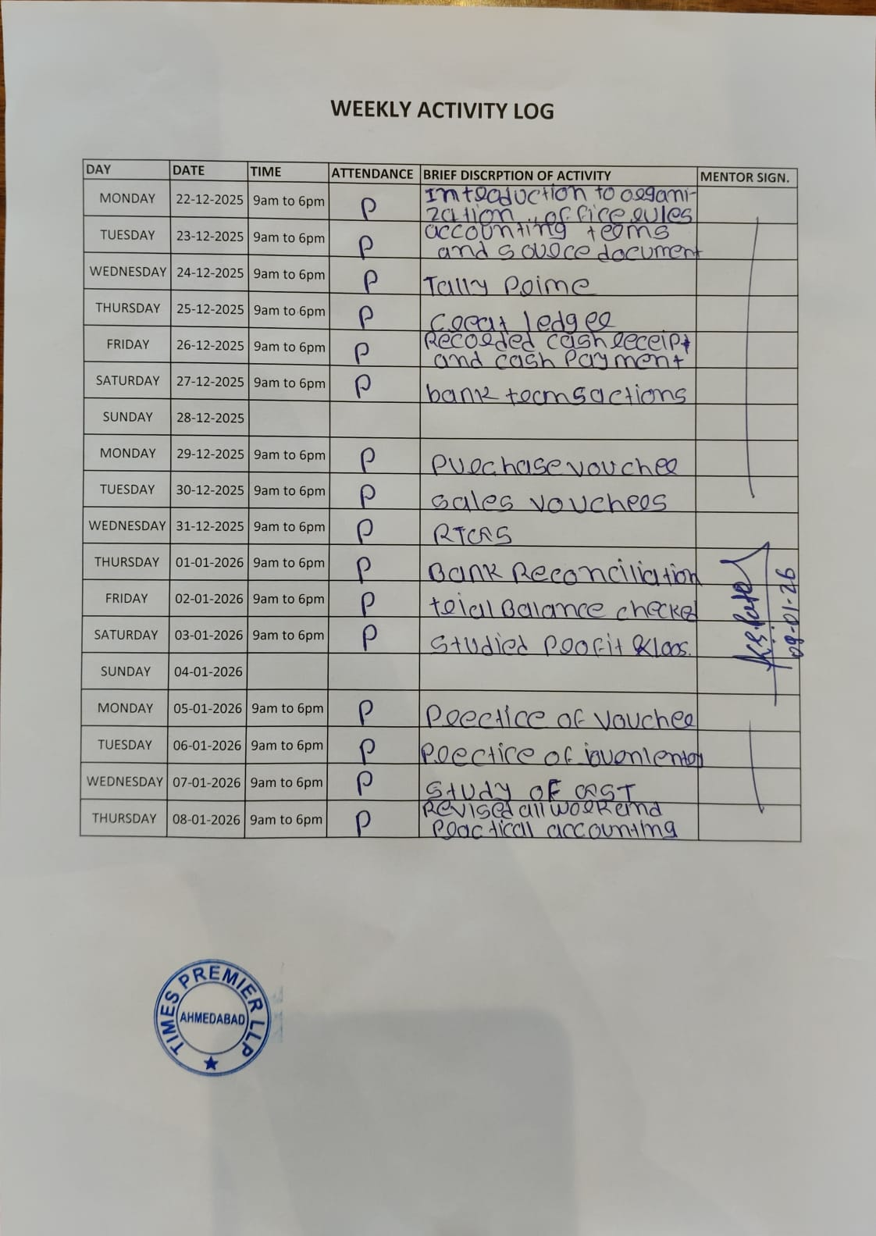
RECOMMENDATION LETTER

ACCEPTANCE LETTER

EVALUATION REPORT